ALBÍN BRUNOVSKÝ
(December 25, 1935 – January 20, 1997)

Born on December 25, 1935 in Zohor, Czechoslovakia, Albín Brunovský was a painter, graphic artist, lithographer, illustrator and a pedagogue, considered one of the greatest Slovak painters of the 20th century.
His strongest memories come from his childhood spent in pine forests. This peaceful atmosphere influenced his illustrations significantly.

1955 – 1961 – Brunovský studies at the Academy of Fine Arts in Bratislava, Graphic Department (under Prof. Vincent Hložník).
1958 – Illustrates his first children’s books for Mladé letá Publishing House: Tricks under the Table by Miroslav Válek and Chocolate Fairy-Tale by Ján Stacho.
1968 – Travels to Italy. This journey inspires him to a series of etchings entitled Bella Italia I – XIII.

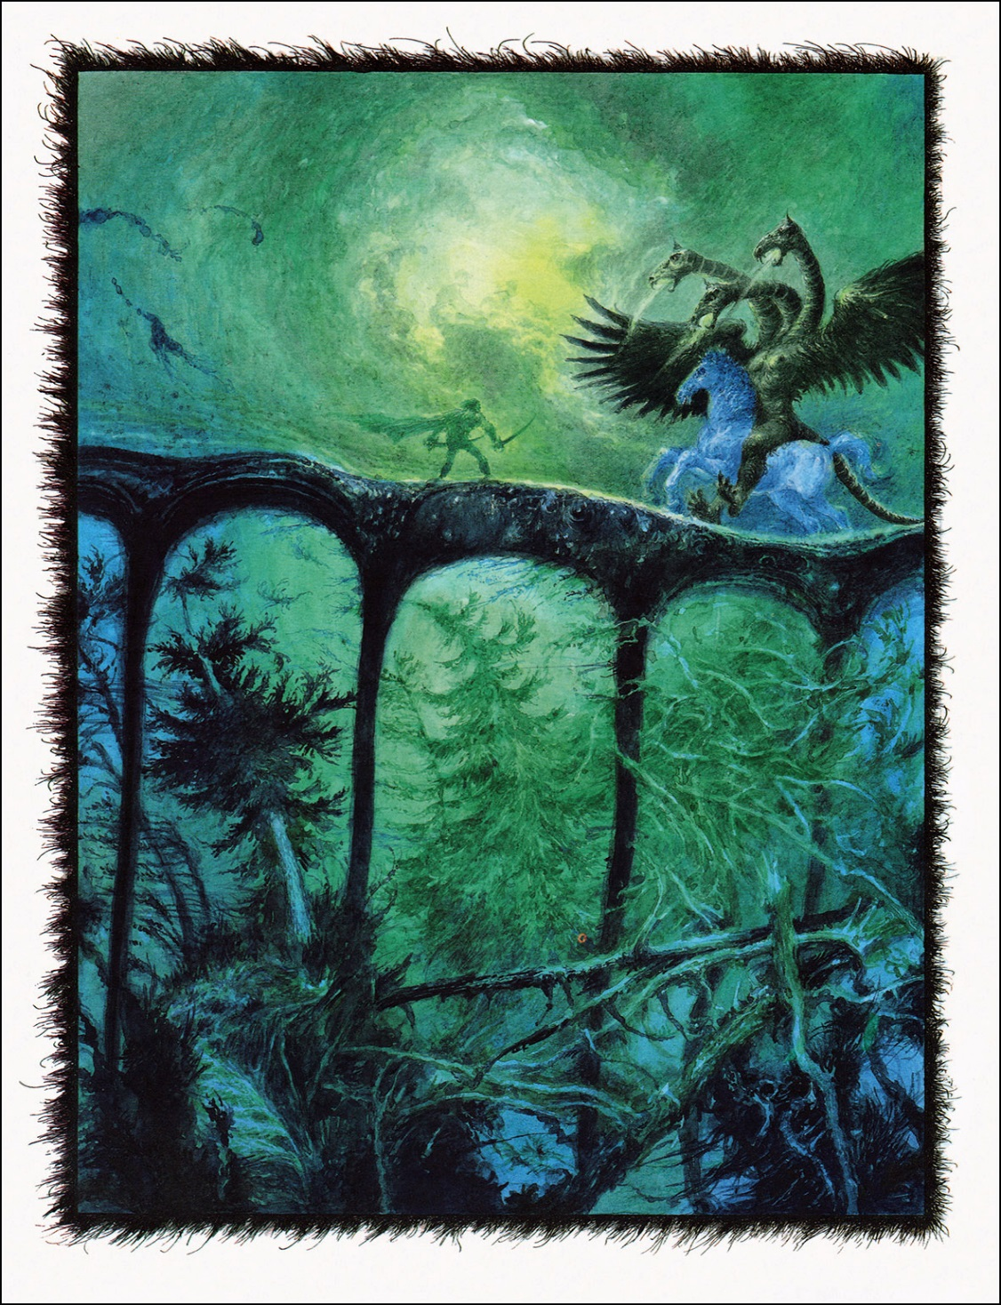
1969 – Brunovský starts painting on Persian nut wood by the classic method, i.e. painting by watercolour, oil glaze and crayon on a chalk baze.
1975 – After he bought a house in his native region of Záhorie as a vacation home, the rediscovered land of lakes and pine woods became a permanent object of his paintings and influenced his works significantly.
1977 – Wins the competition for a new set of Czechoslovak banknotes with the values of 1.000, 10, 20, 50 and 100 crowns. These banknotes were withdrawn from circulation upon the split of Czechoslovakia in 1993.
1981 – Appointed full professor at the Academy of Fine Arts, Bratislava.
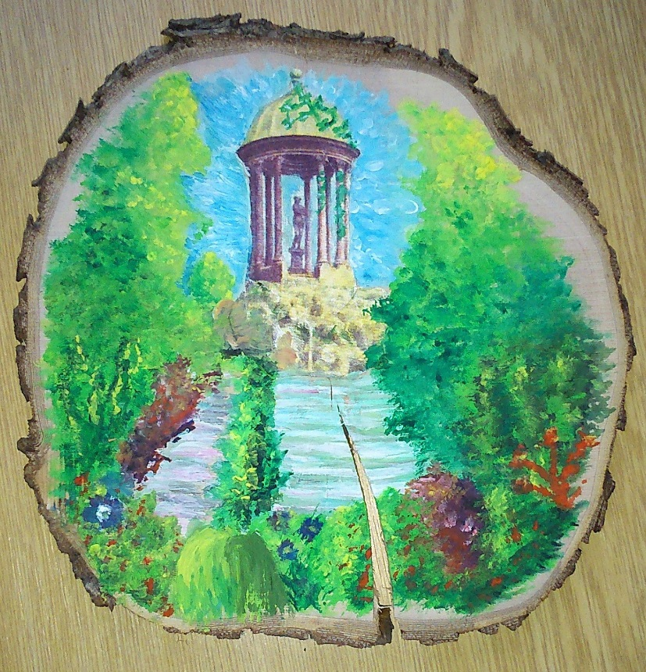
1985 – Awarded the title of National Artist.
K. Rolfová, G. Szirmaiová, 14 years old.
1988 – Travels the USA and gives lectures at universities in Washington, San Francisco, Cleveland, Madison, Chicago and Pittsburgh. He visits Coloman Sokol in Bryn Mawr.
1993 – Designs the setting for the opera Coronation of Poppea by Claudio Monteverdi mounted by the Slovak National Theatre in Bratislava. His son Daniel designed the costumes.
1996 – Brunovský designs a series of 7 wood paintings for the Slovak Parliament in Bratislava.
1997 – Brunovský dies on January, 20 in Bratislava.
Among his most recognized works are book illustrations of:
- THE CHOCOLATE FAITY-TALE by J. Stacho.
- THE BLUE BOOK OF TALES by Ľ. Feldek.
- THE PEACOCK KING AND OTHER STORIES by D’Aulnoy.
- THE SLOVAK TALES by P.Dobšinský.
- THE LITTLE MARMAID by H.Ch. Andersen.

